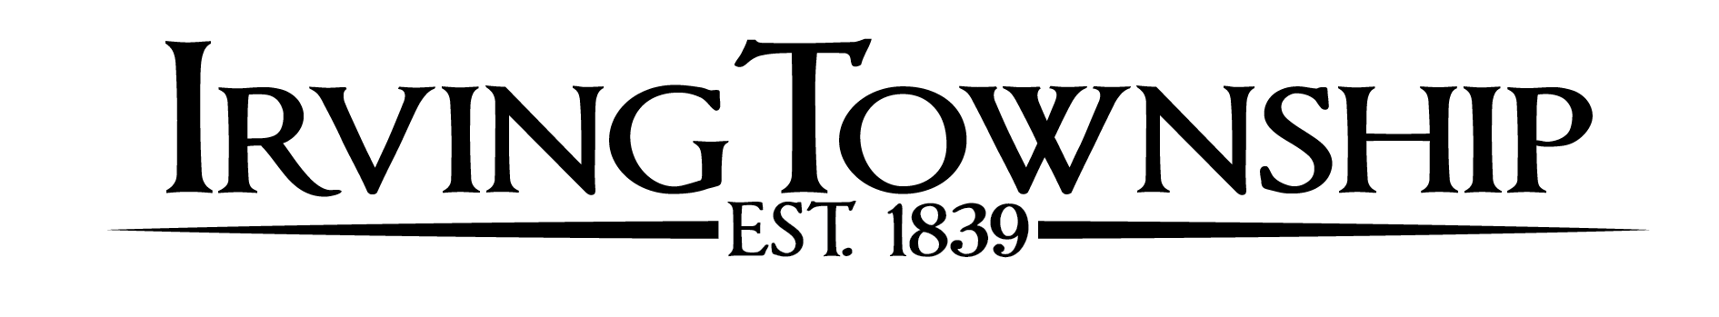
BOARD MEETING AGENDA – April 16, 2024

Call Meeting to order

Pledge of allegiance

Roll Call

Approval of agenda

Rachel Frantz – Barry County Recycling Coordinator

Clerk’s minutes – March 19, 2024

Public Input (3 minute limit)

Unfinished Business

New Business
Trees in German Cemetery

Reports: Fire Reports/Commissioners/Cemetery Sexton/Assessors

Treasurer’s report

Pay bills

Public Input (3 minute limit)

Board Members Comments

Upcoming Dates:
May 21, 2024 – Township Board Meeting 6:30pm

GUIDELINES TO PUBLIC COMMENT

Public comment is welcome and appreciated. Please follow these simple guidelines to ensure all have an opportunity to be heard. All comments and questions will be made through the supervisor. All comments will be made in a courteous and civil manner, profanity and personal attacks will not be tolerated. Please limit the length of your comments to 3 minutes. If you are a member of a group, please appoint a spokesman on behalf of a group (those speaking on behalf of a group may be provided additional time). Please state your name before offering comment.

