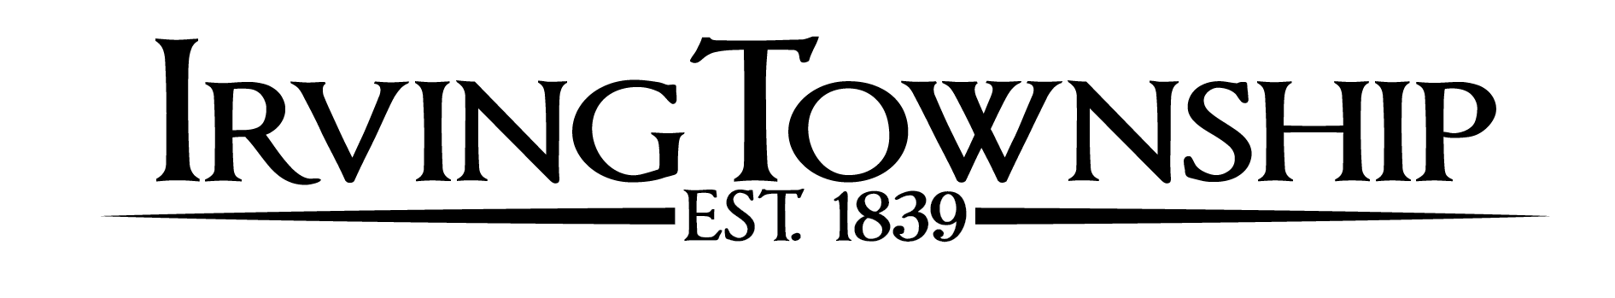

**BOARD MEETING AGENDA – March 18, 2025**

Call Meeting to order

Pledge of allegiance

Roll Call

Approval of agenda

Clerk’s minutes

February 18, 2025

Reports: Fire Reports/Commissioners/Cemetery Sexton/Assessors

Public Input (**3 minute limit**)

Treasurer’s report

Pay bills

Unfinished Business

Village of Middleville Resolution – 2025-4

New Business

Barry County Community Mental Health

Barry County Road Commission 4-Year Plan

Barry County Road Commission Dust Control Adjustments

Birch Rural Fire Association Contract 2025

Township Meeting Schedule 2025

Public Input (**3 minute limit**)

Board Members Comments

Upcoming Dates: April 15, 2025 – Township Board Meeting 6:30pm

GUIDELINES TO PUBLIC COMMENT

Public comment is welcome and appreciated. Please follow these simple guidelines to ensure all have an opportunity to be heard. All comments and questions will be made through the supervisor. All comments will be made in a courteous and civil manner, profanity and personal attacks will not be tolerated. Please limit the length of your comments to 3 minutes. If you are a member of a group, please appoint a spokesman on behalf of a group (those speaking on behalf of a group may be provided additional time). Please state your name before offering comment.